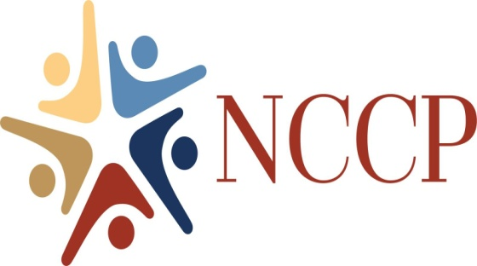

New Castle Community Partnership
2022 Annual Report

The New Castle Community Partnership (NCCP) is moving forward despite the delays that happened during the previous year of 2021 and developed and implemented various project in 2022.
NCCP continues to meet, plan events, and accomplish some of their goals. The Partnership has remained strong with the participation and dedication of their Board members: Laura Fontana as President, Judie Baldini as Vice President, Cindy Snyder as Secretary, and Connie Reese as Treasurer along with Kim Burgmuller, Julie Kirk, Kelli Kruger, Rodney Pratt, Jan Henion, and Valarie Leary as a non-Board advisor.
The New Castle Community Partnership continues to promote, preserve, and enhance Historic New Castle while interacting with the New Castle community. Our goal is to bring into reality projects and events that enhance the public good in New Castle.
There are several activities and accomplishments by the NCCP for 2022.
- The NCCP partnered with the New Castle Jaycees to sponsor the Summer Concerts June thru August.
- We supported and participated in the New Castle Beach Clean Up program in April.
- NCCP sponsored the A Day In Old New Castle event and in partnership with Arasapha Garden Club, Friends of the New Castle Library, New Castle Hundred Lions Club, New Castle Historical Society, and the business community.
- The NCCP supported the Chautauqua Tent Show that was held on the Green.
- The Small Business Saturday event in November was sponsored by NCCP and in partnership with the local New Castle businesses and organization.
- NCCP created a Visitors Guide booklet and an Online version, too. These booklets were distributed to all businesses, restaurants, and other venues in the city.
- We sponsored our first Belgian Beer Festival on Battery Park. It was well attended.
- NCCP was the creator and sponsor of New Castle Restaurant Week, resulting in great offerings by our local restaurants and good attendance from the public.
- The Partnership co-sponsored with New Castle City Library a City Meet and Greet series with over 25 City, non-profits, organizations, and other groups meeting the community and discussing who they are and what they do for the community.
As the New Castle Community Partnership moves into 2023, are planning new events along with the annual events held each year.
- A Day In Old New Castle 18th Century Market Fair and Plein Air Competition.
- A NEW City of New Castle Visitors Guide and Online Guide.
- The Belgian Beer Festival to be held on September 24, 2023.
- Expanding the Small Business Saturday to Small Business Month.
- New signage for 4th Friday Art Loop
- Investigating a permanent digital kiosk.
All our accomplishments are provided through the continued support of all our sponsors:
The New Castle Farmers Market, Jessop’s Tavern, Trustees of the New Castle Common, The City of New Castle, The Anthony and Catherine Fusco Foundation, TransPlus, St. John’s Lodge #2 A.F. and A.M, and many generous individual donors at our Summer Concert Series. We thank you.

